Products--Completion Cases
In 2023, we delivered a 12 MVA transformer to the Philippines. This transformer features a rated power of 12,000 KVA and functions as a step-down transformer, converting a primary voltage of 66 KV to a secondary voltage of 33 KV. We utilize copper for the winding material due to its superior electrical conductivity, thermal efficiency, and resistance to corrosion.
Crafted with state-of-the-art technology and top-grade materials, our 12 MVA power transformer offers exceptional reliability and durability.
At JZP, we guarantee that every transformer we deliver undergoes a comprehensive acceptance test. We are proud to have maintained a flawless zero-fault record for over a decade. Our oil-immersed power transformers are engineered to meet the rigorous standards of IEC, ANSI, and other leading international specifications.

Scope of Supply
Product: Oil Immersed Power Transformer
Rated Power: Up to 500 MVA
Primary Voltage: Up to 345 KV

Technical Specification
12 MVA power transformer specification and data sheet
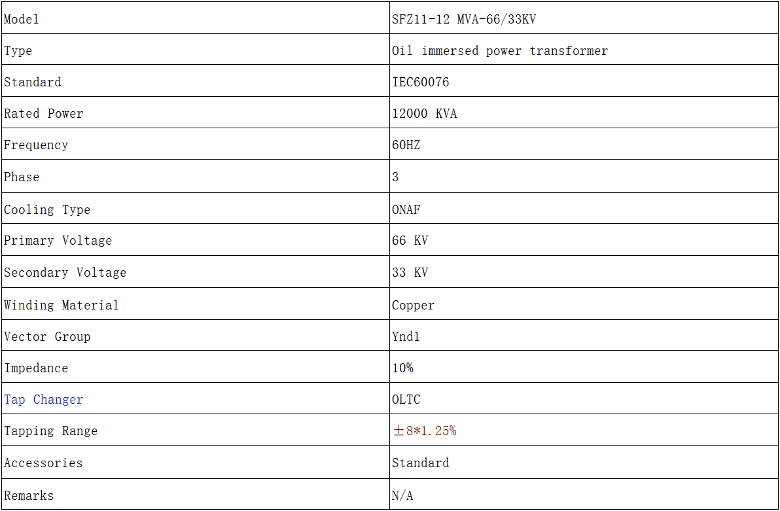

The cooling method of an oil-immersed transformer typically involves using transformer oil as the primary cooling medium. This oil serves two main purposes: it acts as an electrical insulator and helps to dissipate heat generated within the transformer. Here are some common cooling methods used in oil-immersed transformers:

1. Oil Natural Air Natural (ONAN)
- Description:
  - In this method, natural convection is used to circulate the oil within the transformer tank.
  - The heat generated by the transformer windings is absorbed by the oil, which then rises and transfers the heat to the tank walls.
  - The heat is then dissipated into the surrounding air through natural convection.
- Applications:
  - Suitable for smaller transformers where the heat generated is not excessive.

2. Oil Natural Air Forced (ONAF)
- Description:
  - This method is similar to ONAN, but it includes forced air circulation.
  - Fans are used to blow air over the radiator surfaces of the transformer, enhancing the cooling process.
- Applications:
  - Used in medium-sized transformers where additional cooling is required beyond natural air convection.

3. Oil Forced Air Forced (OFAF)
- Description:
  - In OFAF, both oil and air are circulated using pumps and fans, respectively.
  - Oil pumps circulate the oil through the transformer and radiators, while fans force air across the radiators.
- Applications:
  - Suitable for large transformers where natural convection is insufficient for cooling.

4. Oil Forced Water Forced (OFWF)
- Description:
  - This method uses water as an additional cooling medium.
  - Oil is circulated through heat exchangers where water cools the oil.
  - The water is then cooled through a separate system.
- Applications:
  - Used in very large transformers or installations where space for air cooling is limited and higher efficiency is required.

5. Oil Directed Air Forced (ODAF)
- Description:
  - Similar to OFAF, but with a more directed oil flow.
  - The oil is directed through specific channels or ducts to enhance the cooling efficiency at particular hot spots within the transformer.
- Applications:
  - Used in transformers where targeted cooling is needed to manage uneven heat distribution.

6. Oil Directed Water Forced (ODWF)
- Description:
  - This is an advanced cooling method where oil is directed to flow through specific paths within the transformer, ensuring targeted cooling.
  - The heat is then transferred to water via heat exchangers, with forced circulation to efficiently dissipate heat.
- Applications:
  - Ideal for very large or high-power transformers in industrial or utility applications where precise temperature control is critical.

